RESOLUTION NO.__________

RE: CERTIFICATE OF APPROPRIATENESS UNDER THE
PROVISIONS OF THE ACT OF THE PENNSYLVANIA
LEGISLATURE 1961, JUNE 13, P.L. 282 (53
SECTION 8004) AND BETHLEHEM ORDINANCE NO.
3952 AS AMENDED.

The applicant proposes to replace the roof with GAF slateline shingles at
255 E. Wall St.

NOW, THEREFORE, BE IT RESOLVED by the Council of the City of Bethlehem that a Certificate of Appropriateness is hereby granted for the proposal.

Sponsored by: (s)

(s)

ADOPTED BY COUNCIL THIS DAY OF

(s)
President of Council

ATTEST:

(s)
City Clerk

HISTORICAL & ARCHITECTURAL REVIEW BOARD

The applicant proposes to replace the roof with GAF slateline shingles at 255 E. Wall St.

APPLICATION #2:

Stephen Pallone
225 E. Wall St.
Bethlehem, PA 18018

OWNER:

__________________________________________________________________________

The Board upon motion by Phil Roeder and seconded by Marsha Fritz adopted the proposal that City Council issue a Certificate of Appropriateness for the following:

- Roof to be replaced with GAF slateline, Antique slate shingles.

2. Aluminum or copper drip edge, same color as trim.

3. The motion was unanimously approved.

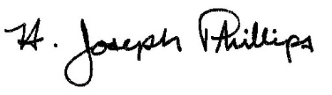 By:__H. Joseph Phillips___________

Title: __Historic Officer____________

Date of Meeting: September 5, 2018

